1. Open website: <https://www.hipaaspace.com/medical_billing/coding/national_provider_identifier/npi_number_lookup.aspx> in chrome browser

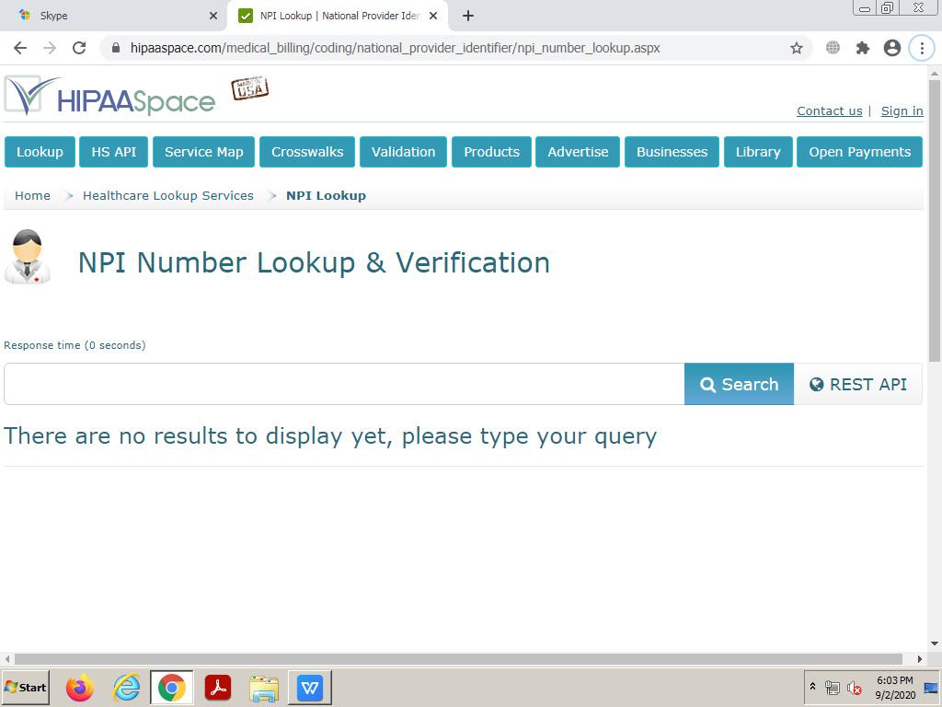

1. We will provide you Provider name and NPI number in excel

**Example: Raymond Zimmer MD, NPI Number: 1013150499**

1. Enter NPI number in search box as it appears below

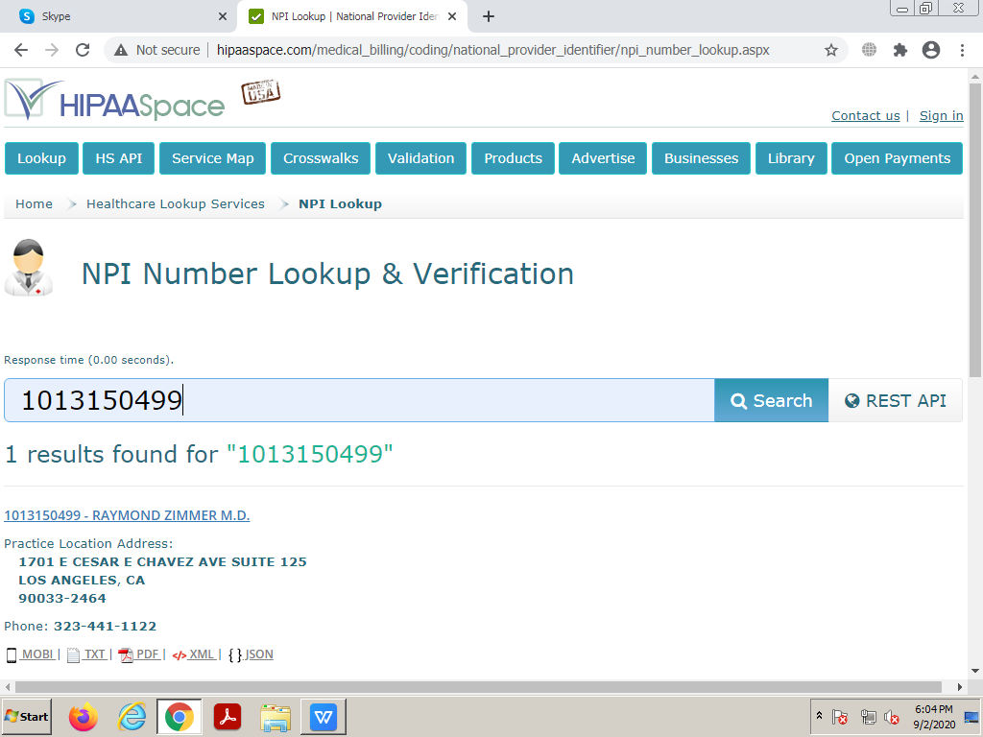

1. As we will enter NPI number in search box and hit on search button, it will come up with Provider details as shown below

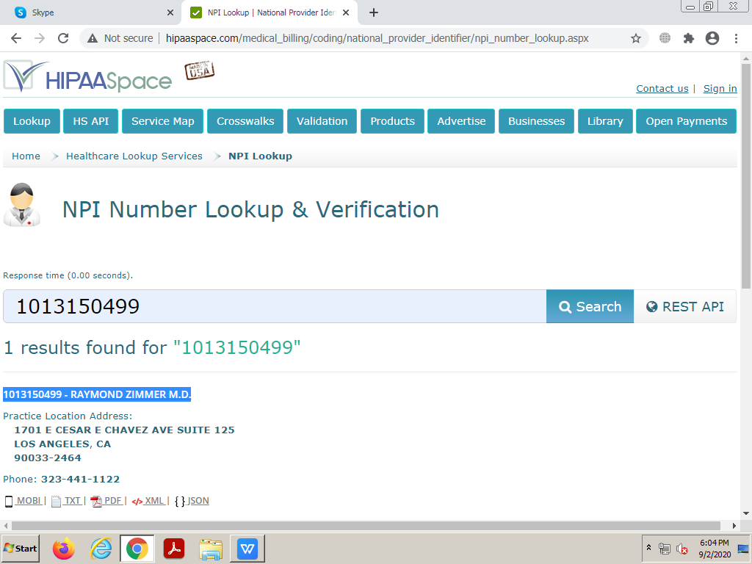

1. Match Provider name from excel and pick Name row in excel as highlighted above